**ASSIGNMENT 16.1**

PROBLEM STATEMENT:

Given a List of numbers - List[Int](1,2,3,4,5,6,7,8,9,10)

Solution:

Creation of List:

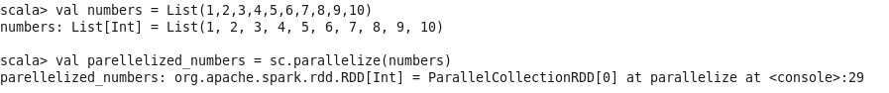

(i) **Find the sum of all the numbers**

Output:



(ii) **Find the total elements in the list.**

Output:



(iii) **Calculate the average of numbers in the list.**

Output:



(iv) **Find the sum of all even numbers in the list.**

Output:

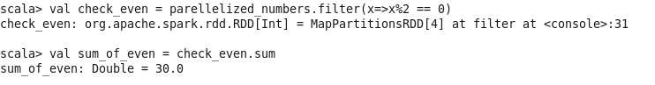

(v) **Find the total number of elements in the list both divisible by 5 and 3.**

Output:



